CSA-FIN-RD-0765

Canadian Space Agency
Office of the Chief Financial Officer (OCFO)

Cost Analysis Data Requirements (CADRe)

PART A

Mission : LUMEN Exoplanet Observatory

Key Decision Point : CDR

EPMO Gate : Gate R3

Draft 3.0

August 19, 2026

This Page Intentionally Left Blank
Revision History
Rev. | Description | Prepared by | Date
Draft 1.0 | Initial draft | MB | 19 Aug 2026

Table of Contents
This Page Intentionally Left Blank
1 Introduction 7
1.1 Purpose of this document 7
2 General Descriptive Information 7
2.1 Mission Overview 7
2.2 Strategic Objectives 8
2.3 Selected Mission Requirements 9
2.4 High-Level Mission Architecture 11
3 Space Segment Description 12
3.1 Spacecraft Bus 12
4.1 CEAM Payload 12
5 Launch Segment description 14
6 Ground Segment and Mission Operations 14
7 Ground Segment and Mission Operations 14
8 Systems Engineering and Project Management Approach 15
8.1 TRL Levels and Heritage 15
8.2 Phasing Logic and Naming conventions 15
8.3 CSA PRoject Milestones 16
8.4 Safety and Mission Assurance 17
8.5 Prototyping (MODEL Philosophy), Qualification and Verification Strategy 17
8.6 Sparing Straegy 17
8.7 Risk Assessment 18
8.8 Organizational Breakdown Structure 18

List of Figures
FIGURE PAGE
Figure 1 – CEAM instrument on the LUMEN Observatory] 8
Figure 2 – Simplified optical path from Telescope to Focal Plane Array 13

List of TABLES
Table 1 - Strategic Alignment 8
Table 2 – Selected SYSTEM Requirements 9

Introduction

Purpose of this document
CADRE Part A provides a concise, standardized synopsis of the mission or project to support costing and analysis activities. Its primary purpose is to consolidate information from multiple technical and programmatic source documents into a single, normalized reference.
Specifically, CADRE Part A:
- Summarizes key mission characteristics in a consistent and structured format
- Aggregates information drawn from multiple authoritative technical documents
- Reduces the need for analysts to repeatedly consult disparate source materials
- Ensures a common baseline description is used across analyses
- Improves efficiency, traceability, and consistency in downstream costing work
In practical terms, CADRE Part A functions as a time-saving reference document that enables analysts to quickly understand the mission context without re-interpreting or reconciling multiple source documents.

General Descriptive Information

Mission Overview
The LUMEN Exoplanet Observatory is a proposed European-led space science mission dedicated to discovering and characterizing planets orbiting nearby stars. Its primary objective is to identify potentially habitable worlds and examine the physical and chemical properties of their atmospheres. The mission would study planets of different sizes and temperatures, ranging from hot gas giants to small rocky planets located within the habitable zones of their host stars.
The observatory would be placed in a stable orbit near the Sun–Earth L2 region, where it could conduct long-duration observations with limited interruptions from Earth. A medium-aperture telescope would collect visible and infrared light from selected planetary systems. LUMEN would use several complementary observing techniques, including transit photometry, transit spectroscopy and direct measurement of changes in a star’s light as a planet moves through its orbit. These observations would help determine planetary size, orbital characteristics, atmospheric composition and temperature.
Canada would contribute the Canadian Exoplanet Atmospheric Mapper (CEAM), a specialized scientific instrument designed to separate incoming light into multiple spectral bands. CEAM would search for atmospheric signatures associated with water vapour, carbon dioxide, methane, clouds and other compounds. Canada would also provide elements of the instrument electronics, calibration system, data-processing software and scientific analysis capability.
The European mission partner would be responsible for the spacecraft platform, telescope, launch service, mission operations and overall system integration. Canadian scientists and engineers would participate in instrument development, mission planning, commissioning and scientific operations. In return for its contribution, Canada would receive guaranteed access to mission observations and opportunities for Canadian researchers and students.
LUMEN is envisioned as a five-year mission, with the possibility of an extended operational phase. Its results would provide a catalogue of characterized exoplanets, identify high-priority targets for future missions and improve scientific understanding of how planetary systems form and evolve.
The diagram now shows the Canadian Exoplanet Atmospheric Mapper (CEAM) as the red internal module, with a prominent arrow pointing directly to its location inside the observatory.
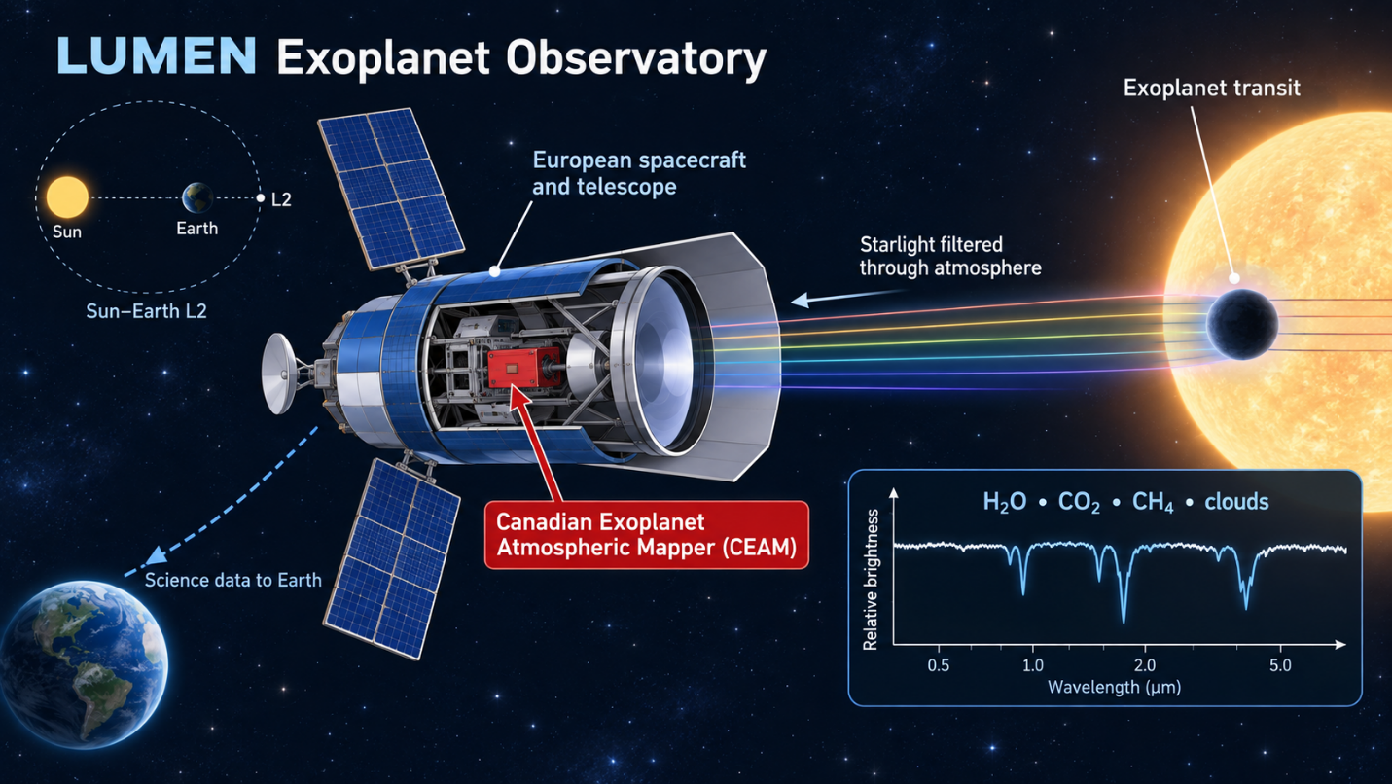
Figure 1 – CEAM instrument on the LUMEN Observatory]

Strategic Objectives
Consistent with the Government of Canada's Space Policy Framework, the WFS mission supports the following 2 main strategic goals:
Table 1 - Strategic Alignment
 | Strategic Goals | Space Strategy
5 | DISCOVER | Expand human knowledge through scientific discoveries.  The investment will expand human knowledge by enabling Canadian scientists to detect and characterize exoplanets and study the composition of their atmospheres.
4 | ENABLE | Position the space sector to help grow the economy  The investment will strengthen Canada’s space sector by advancing domestic expertise and technologies in space instrumentation, data processing and exoplanet science through an international partnership.
2 | INSPIRE | Inspire Canadians to reach for the stars.  The mission’s search for potentially habitable worlds will engage Canadians and inspire students and researchers to pursue careers in science, technology, engineering and space exploration.

Additionally, LUMEN contributes to Space Diplomacy through international partnerships.

Selected Mission Requirements
The following presents a summary of selected mission requirements. The complete and authoritative set of requirements is contained in the Mission Requirements Document (link MRD)
Level 1 Scientific Requirements
- Exoplanet Discovery: Detect exoplanets orbiting nearby stars and determine their basic orbital characteristics.
- Planetary Characterization: Measure the size, temperature and other physical properties of selected exoplanets.
- Atmospheric Composition: Identify and characterize gases, clouds and aerosols present in exoplanet atmospheres.
- Planetary Habitability: Assess the environmental conditions of rocky exoplanets and identify promising candidates for future studies of habitability and potential biosignatures.

Table 2 – Selected SYSTEM Requirements
The following are suitable preliminary system-level requirements for the fictional LUMEN mission. The numerical values are intentionally conceptual and would need confirmation through mission trade studies.
Cost- and complexity-driving system requirement | Preliminary requirement | Principal cost and complexity effects
Telescope aperture | The observatory shall provide a telescope with an effective aperture of at least 2.0 m. | Drives telescope size, mirror manufacturing, structural stability, launch volume, spacecraft mass and launch-vehicle selection.
Spectral coverage | The observatory shall measure exoplanet spectra over a wavelength range of approximately 0.6–5.0 μm. | Requires multiple detector technologies, optical channels, filters, calibration equipment and thermal control.
Spectral resolution | CEAM shall provide selectable spectral resolving power of approximately R = 100–1,000, depending on the observing mode. | Drives optical design, detector count, instrument calibration, data volume and processing complexity.
Measurement stability | The observatory shall maintain the photometric and spectroscopic stability required to detect variations in stellar brightness of approximately 20 parts per million during a transit observation. | Drives detector performance, thermal stability, calibration, contamination control and systematic-error correction.
Pointing performance | The spacecraft shall maintain line-of-sight stability within approximately 20 milliarcseconds during science observations. | Drives attitude-control sensors and actuators, structural stability, vibration isolation and guidance software.
Thermal environment | CEAM detectors shall operate at temperatures below approximately 70 K, with temperature variations controlled during observations. | May require passive cooling, mechanical cryocoolers, thermal shielding, specialized materials and additional power.
Operational orbit | The observatory shall operate in a Sun–Earth L2 halo or Lissajous orbit and support station-keeping throughout the mission. | Drives launch energy, propulsion, navigation, communications range, radiation design and ground operations.
Mission life | The observatory shall provide at least five years of science operations, with consumables and reliability provisions supporting a goal of eight years. | Drives redundancy, component quality, fuel capacity, reliability analysis, testing and obsolescence management.
Communications and data | The observatory shall return at least 100 gigabits of science and engineering data per day through the European ground segment. | Drives antenna size, transmitter power, onboard storage, communications scheduling and ground infrastructure.
Canadian instrument interface | The European observatory shall accommodate CEAM as a separately developed Canadian instrument and provide defined mechanical, electrical, thermal, optical, software and data interfaces. | Drives international coordination, interface control, verification facilities, schedule reserves and joint integration and testing.

High-Level Mission Architecture
Owned and operated by ESA, the mission consists of the following segments, howere CSA is only responsible for the Canadian Exoplanet Atmospheric Mapper (CEAM).
- A Government Segment: consisting of government resources for oversight and their associated management costs such as T&L
- A Space Segment: consisting of four spacecrafts with a platform/bus and a infrared instrument.
- A Launch Segment: consisting of the launcher and launch service provider, provided by ESA.
- A Ground Segment: consisting of facilities and equipment to plan and command acquisitions, as well as, to receive, archive and process data acquired by the satellite, provided by ESA.
- An Ops Segment: consisting of personnel to handle real-time operations and some O&M costs, provided by ESA
- A Science Segment: consisting of scientific leadership, research teams, and supporting infrastructure responsible for mission science planning, calibration and validation, data analysis, scientific data products, user support, and the maximization of scientific return from the mission.

Space Segment Description
The space segment consists of a constellation of 4 spacecrafts, each with a bus and a payload. The 4th spacecraft is an on-orbit spare.

Spacecraft Bus
- Vespera-L2 Spacecraft Platform
The Vespera-L2 is a fictional European spacecraft platform proposed as the service module for the LUMEN Exoplanet Observatory. It would be developed by the fictional prime contractor Elystria Orbital Systems and adapted specifically for long-duration astronomical observations near the Sun–Earth L2 point. The platform would support the European telescope and payload module, including Canada’s Canadian Exoplanet Atmospheric Mapper (CEAM).
Vespera-L2 would provide the observatory’s structural support, electrical power, propulsion, communications, command and data handling, attitude control and thermal-management services. A modular mechanical interface would connect the relatively warm service module to the cryogenic payload module while limiting the transfer of heat and vibration to the telescope and scientific instruments. Deployable solar arrays would generate electrical power, while rechargeable batteries would maintain spacecraft functions during launch and contingency operations.
A high-precision attitude-control system using star trackers, reaction wheels and fine-guidance information from the payload would maintain the stable pointing required for exoplanet transit observations. Small electric-propulsion thrusters would perform trajectory corrections, L2 orbit insertion, station-keeping, momentum unloading and end-of-mission disposal. The platform would also incorporate redundant flight computers, fault-detection and recovery functions, and radiation-tolerant electronics to support autonomous operations far from Earth.
Science and engineering data would be stored in a redundant onboard memory system and transmitted to the European ground segment through a steerable high-gain antenna. The platform would be designed for a minimum five-year operational mission, with sufficient consumables and reliability provisions to support a possible extension to eight years. Its modular payload interfaces would allow CEAM to be developed and tested in Canada before delivery for integration with the European observatory.

CEAM Payload
The Canadian Exoplanet Atmospheric Mapper (CEAM) is the principal Canadian contribution to the LUMEN Exoplanet Observatory. The instrument receives light collected by the European telescope and measures small variations in the spectrum of a star as an exoplanet passes in front of it. These measurements are used to identify water vapour, carbon dioxide, methane, clouds and other atmospheric characteristics.
CEAM is notionally developed by the fictional Canadian prime contractor Maple Arc Space Instruments. The instrument has an estimated mass of 140 kg, requires approximately 300 W during science observations and operates over a spectral range of 0.6–5.0 μm.
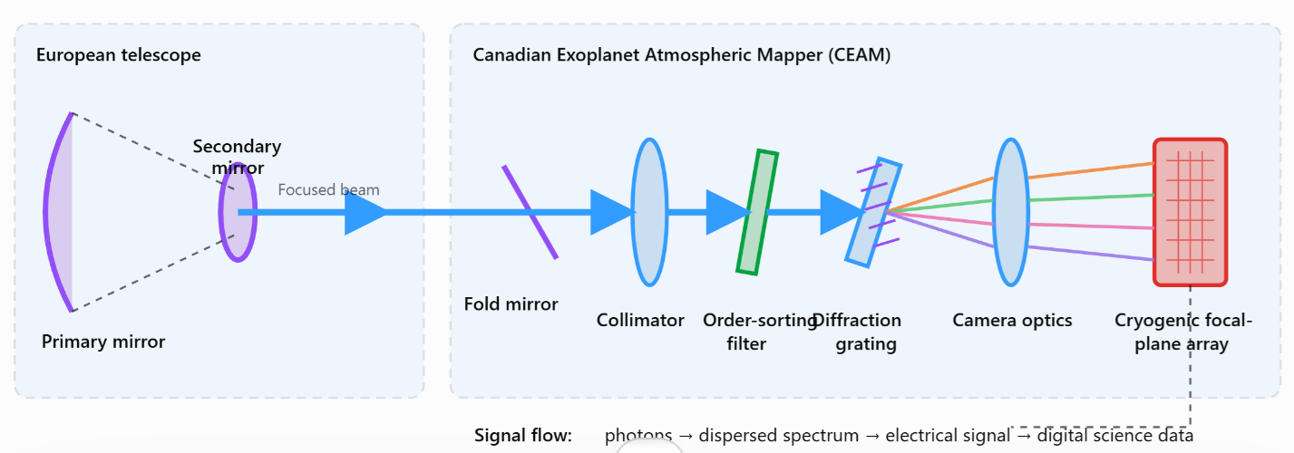
Figure 2 – Simplified optical path from Telescope to Focal Plane Array

Optical Bench
The optical components are mounted on a lightweight carbon-fibre-reinforced polymer (CFRP) optical bench designed to provide high stiffness and low thermal expansion. The bench incorporates precision metallic or composite inserts for mounting and alignment of the optical components. Its laminate configuration, joints and surface treatments are selected to minimize moisture release, dimensional changes and optical misalignment during launch, cooldown and operation in the cryogenic space environment.

Optical Subsystem
The StarPath Optical Assembly, supplied by the fictional company Northlight Precision Optics, receives the telescope beam and directs it toward CEAM’s scientific channels. Mirrors, filters and beam splitters divide the incoming light into visible, near-infrared and mid-infrared wavelength bands.
The SpectrumArc Spectrometer, developed by Maple Arc Space Instruments, separates the incoming light into its component wavelengths. It provides multiple observing modes with spectral resolving power between approximately R = 100 and R = 1,000. The spectrometer contains diffraction gratings, precision mirrors and selectable optical elements but has few moving parts to reduce mechanical risk.
The DeepView Focal Plane Detector Assembly, supplied by the fictional company Redstone Photon Devices, converts the dispersed light into digital measurements. Separate visible and infrared detector arrays provide sensitivity across CEAM’s wavelength range. The detectors are designed for low noise, high stability and repeated observations of very small changes in stellar brightness.

Cryogenic and Thermal-Control Subsystem
The FrostLine Thermal System, developed by the fictional company Cryovanta Space Technologies, maintains the infrared detectors below approximately 70 K. It combines passive radiators, thermal straps, insulation, heaters and a miniature mechanical cryocooler. Precision temperature sensors and control electronics minimize thermal variations that could affect scientific measurements.

Calibration Subsystem
The TrueStar Calibration Unit, supplied by Northlight Precision Optics, provides stable internal light sources and reference signals. It is used to measure detector response, identify instrument drift and distinguish genuine exoplanet signatures from changes caused by the instrument. Calibration observations are performed before, during and after selected science campaigns.

Instrument Electronics
The PolarCore Electronics Unit, developed by the fictional company Avenor Space Microsystems, distributes electrical power, controls the detectors and mechanisms, collects housekeeping telemetry and digitizes scientific measurements. Redundant processing and power channels allow the instrument to continue operating following selected equipment failures.

Instrument Data-Processing Unit
The SpectraForge Processing Unit, supplied by the fictional company Quanta Harbour Technologies, performs initial processing, compression and storage of CEAM data. It removes detector artefacts, packages observations and transfers the resulting data to the European spacecraft computer for transmission to Earth.

Instrument Software
CEAM flight software commands the instrument, controls observing modes, monitors health and safety, and coordinates detector readout and calibration activities. Canadian-developed ground software converts raw measurements into calibrated spectra and supports the identification of atmospheric gases, clouds and aerosols.

Launch Segment description
The LUMEN Observatory will be launched aboard the fictional Aquila-6 launch vehicle and injected into a transfer trajectory toward the Sun–Earth L2 point. Following separation from the launch vehicle, the observatory will use its onboard propulsion system to perform trajectory corrections and enter its operational L2 orbit.
ESA is providing launch.

Ground Segment and Mission Operations
The proposed approach is for the European Space Agency (ESA) to provide the complete ground segment and assume responsibility for operating the LUMEN Observatory and the Canadian Exoplanet Atmospheric Mapper (CEAM). ESA would perform spacecraft and instrument command and control, ground-station communications, mission planning, flight dynamics, L2 orbit maintenance, health monitoring and anomaly response. CEAM observing modes, detector operations, calibration activities and thermal-control functions would be incorporated into the overall mission-operations plan and commanded through the European ground segment.
The CEAM passive optical assembly would not require routine commanding. ESA would nevertheless monitor its associated temperatures, alignment indicators and instrument-performance telemetry as part of normal observatory operations. Canadian instrument specialists would provide technical documentation, operating constraints and expert support to ESA, particularly during commissioning, calibration campaigns and the investigation of instrument anomalies.
Observation data would be received through the European ground network and transferred to a Canadian science data centre. The science data centre would process, validate and archive CEAM observations and associated engineering and calibration data. It would also generate standardized scientific products and maintain the information required to trace processed results back to the original observations and calibration files.
Canadian researchers would access CEAM scientific products through the Canadian Astronomy Data Centre (CADC). The CADC would provide the user-facing archive, search tools and data-access services required by the Canadian astronomy community. Data-transfer arrangements, access rights, proprietary periods, cybersecurity requirements, metadata standards and long-term preservation responsibilities would be established through agreements between Canada, ESA and the participating science organizations.

Science Segment

Systems Engineering and Project Management Approach

TRL Levels and Heritage

Phasing Logic and Naming conventions
The following are the phases in terms of costing:
Costing Nomenclature | Phase Description according to Costing Standards | Corresponding Name for Project team
PREP 1 | Prototyping Activities (before Gate 1) | N/A
PREP 2 | Prototyping Activities (during Phase 0/A) | N/A
Phase 0 | Concept & Feasibility Studies | Phase 0
Phase A | System Definition | Phase A
Phase B | Preliminary Design | Phase B
Phase C | Detailed Design | Phase C
MAIT | Manufacturing, Assembly, Integration and Test (of Canadian Systems, Subsystems and Components) | Phase D
ATLO | and Test | Phase D
ATLO | Mission Level Assembly, Test, and Launch Operations (ATLO) | Phase D
Outbound Cruise | Outbound Cruise is the interplanetary journey ending with approach and orbit insertion at the destination | Cruise
Phase E | Nominal Operations (per design life) | Phase E
Phase X | Extended operations (mission extension) | Extended ops
Phase F | Disposal (audit) | Phase F
Phase G | Post-Mortem data utilization | N/A

The Cadre part C has the most up-to date schedule, these dates are notional.
 | Phase 0 | Phase A | Phase B | Phase C | Phase D | Operations | Mission Extension
Start Date | 2017-Aug-15 | 2021-Jul-15 | 2023-Nov-01 | 2025-Jul-01 | 2026-Nov-26 | 2028-Apr-26 | 2039-Apr-26
End Date | 2019-Jul-15 | 2023-Oct-31 | 2025-Jul-29 | 2026-Nov-01 | 2028-Apr-25 | 2039-Apr-26 | 2039-Jul-25
Duration (m) | 23.0 mo | 27.6 mo | 20.9 mo | 16.0 mo | 17.0 mo | 132.1 mo | 3.0 mo

CSA PRoject Milestones
The project has not created a schedule baseline yet. Assuming instrument level milestones will drive the CSA need dates.
Instrument Phases |  | Major Milestone | Milestone Date
Phase 0 | MCR | Mission Concept Review
Phase A | SRR | System Requirements Review
Phase B | PDR | Preliminary Design Review
Phase C | CDR | Critical Design Review
MAIT | PSR | Pre-Ship Review
ATLO
ATLO | AR | Acceptance Review or you could use the PSR to the launch site
ATLO | L | Launch
Cruise and EDL |  | Orbit insertion at Europe
Cruise and EDL |  | Entry descent landing
Cruise and EDL |  | Swimming begins
Phase E |  | Start of Nominal Ops
Phase E |  | End of Nominal Ops
Phase X |  | End of Life
Sample Return phase |  | When the sample arrived on Earth

Safety and Mission Assurance
Mission Class B

Prototyping (MODEL Philosophy), Qualification and Verification Strategy
Consistent with the intent of the GSFC GOLD Rules for a Class B mission, CEAM would use a conservative development and verification approach emphasizing design maturity, qualification margins, redundancy and testing at progressively higher levels of assembly. An Engineering Model (EM) would be produced early to validate the optical path, detector performance, electronics, software, thermal behaviour and spacecraft interfaces. A structurally representative model could also be used to confirm mechanical interfaces and predict launch-load responses.
A coupled Structural–Thermal–Optical Performance (STOP) analysis would be conducted and maintained throughout instrument development. Structural and thermal models would predict how launch loads, spacecraft pointing, equipment dissipation and changes in the operational thermal environment could deform or misalign the CFRP optical bench, mirrors, gratings and focal-plane assembly. The resulting distortions would be transferred into the optical model to assess line-of-sight error, focus, wavefront quality, spectral registration and overall scientific performance. Analytical models would be correlated using structural, thermal-vacuum and optical-alignment test results and updated as the design matures.
New or significantly modified hardware would normally be verified using a dedicated Qualification Model (QM) subjected to environmental levels and durations exceeding those expected in flight. The Flight Model would subsequently undergo acceptance testing to screen for manufacturing and workmanship defects. A Protoflight Model (PFM) approach, in which the flight unit is tested at qualification levels for reduced durations, could be considered for mature, flight-proven components; however, its use would require documented risk acceptance and would not normally be preferred for new or mission-critical CEAM assemblies.
Testing would begin at the component and unit levels and progress through instrument-subsystem, complete-instrument and spacecraft-level verification. Testing would include functional performance, vibration, acoustic, shock, electromagnetic compatibility, thermal-vacuum, thermal balance, optical alignment, calibration and end-to-end data-flow testing. Environmental testing would be followed by functional checks to identify degradation or latent failures.
Electrical, electronic and electromechanical parts would be selected from approved space-qualified part families or supported by documented screening, qualification and radiation analysis. Mission-critical functions would incorporate fault detection, isolation and recovery, together with selective redundancy in power supplies, instrument electronics, heaters, sensors and data paths. Where redundancy is impractical—particularly for passive optics—the design would rely on adequate margins, STOP analysis, robust qualification, contamination control and conservative workmanship standards.

Sparing Straegy
CEAM would use a subassembly-level sparing strategy focused on critical, long-lead and failure-prone hardware. Qualified flight spares would be maintained for detector electronics, data-processing units, mechanisms and communication interfaces. Common components would be used where practical to reduce the number of unique spares.

Passive optical elements and the CFRP optical bench would not normally have complete flight spares because of their cost and specialized manufacturing. Instead, spare mirrors, filters, gratings, mounts and interface hardware would be procured where practical and cost effective.

Engineering models and ground-support equipment would be retained after launch to reproduce anomalies and validate software or operational changes.

Risk Assessment
The project team shall produce a risk register (ref CADRe part C)

Organizational Breakdown Structure
The following is an illustrative partnership structure. Industry, university and investigator names are fictional; government and space-agency names are real.

Space Agencies and Government Organizations
Partner | Country/region | Proposed role
European Space Agency (ESA) | Europe | Mission lead; spacecraft, telescope, launch, ground segment, mission operations and command and control of CEAM.
Canadian Space Agency (CSA) | Canada | Sponsor and manager of the Canadian contribution; responsible for CEAM development oversight, Canadian industrial contracts and international interfaces.
Japan Aerospace Exploration Agency (JAXA) | Japan | Contributes infrared detector technology, calibration support and scientific expertise in exoplanet atmospheric observations.
National Research Council Canada (NRC) | Canada | Provides the Canadian science-data infrastructure and access to observations through the Canadian Astronomy Data Centre.
Innovation, Science and Economic Development Canada (ISED) | Canada | Supports spectrum coordination, industrial participation and the development of Canadian space technologies.
Global Affairs Canada (GAC) | Canada | Supports international agreements, technology-transfer arrangements and diplomatic coordination with European, Japanese and Slovenian partners.
Slovenian Space Office | Slovenia | Coordinates Slovenia’s national contribution, industrial participation and relationship with ESA.
Slovenian Research and Innovation Agency | Slovenia | Supports Slovenian scientific participation, research grants and university-led data analysis.

Industrial Partners
Fictional partner | Country | Proposed role
Elystria Orbital Systems | Europe | European prime contractor responsible for the LUMEN spacecraft, telescope integration and observatory-level verification.
Maple Arc Space Instruments | Canada | Canadian prime contractor responsible for CEAM design, assembly, integration and testing.
Northlight Precision Optics | Canada | CEAM mirrors, filters, diffraction gratings and optical alignment equipment.
CarbonNorth Structures | Canada | CFRP optical bench, precision inserts and instrument structural assembly.
Cryovanta Space Technologies | Canada | Cryogenic cooling equipment, thermal straps, radiators and temperature-control hardware.
Avenor Space Microsystems | Canada | Instrument electronics, power-conditioning units and radiation-tolerant data-processing hardware.
Velora Photonic Systems | Slovenia | Optical-fibre assemblies, calibration light sources and optical-performance test equipment.
Karstline Space Electronics | Slovenia | Detector readout electronics, temperature sensors and instrument-support electronics.
Hinodeka Detector Technologies | Japan | Visible and infrared focal-plane detector arrays developed in cooperation with JAXA.

Participating Academic Institutions
Fictional institution | Country | Proposed scientific contribution
Starlake University – Centre for Exoplanet Science | Canada | Leads Canadian science planning, atmospheric retrieval and interpretation of CEAM observations.
Northern Dominion Institute of Astrophysics | Canada | Develops calibration algorithms, observation simulations and stellar-activity correction methods.
Adriatic University of Science and Technology | Slovenia | Studies atmospheric chemistry, clouds and aerosols in rocky exoplanets.
Ljublana Institute for Computational Astronomy | Slovenia | Develops machine-learning tools and atmospheric-retrieval software.
Hoshikawa University – Laboratory for Planetary Spectroscopy | Japan | Provides molecular spectroscopy, detector characterization and comparative planetary science.
European Institute for Distant Worlds | Europe | Coordinates the international science team, target selection and scientific-product validation.

Scientific Leadership (Principal Investigator)
Fictional position | Fictional individual | Affiliation
LUMEN Principal Investigator | Dr. Eliana Vautrin | European Institute for Distant Worlds
Canadian Principal Investigator for CEAM | Dr. Maya Desrosiers | Starlake University
CEAM Instrument Scientist | Dr. Adrian Kells | Maple Arc Space Instruments
Slovenian Science Co-Investigator | Dr. Talia Zoren | Adriatic University of Science and Technology
Japanese Science Co-Investigator | Dr. Renji Amahara | Hoshikawa University
Canadian Data-System Lead | Dr. Noah Bellavance | Northern Dominion Institute of Astrophysics

